Job profile
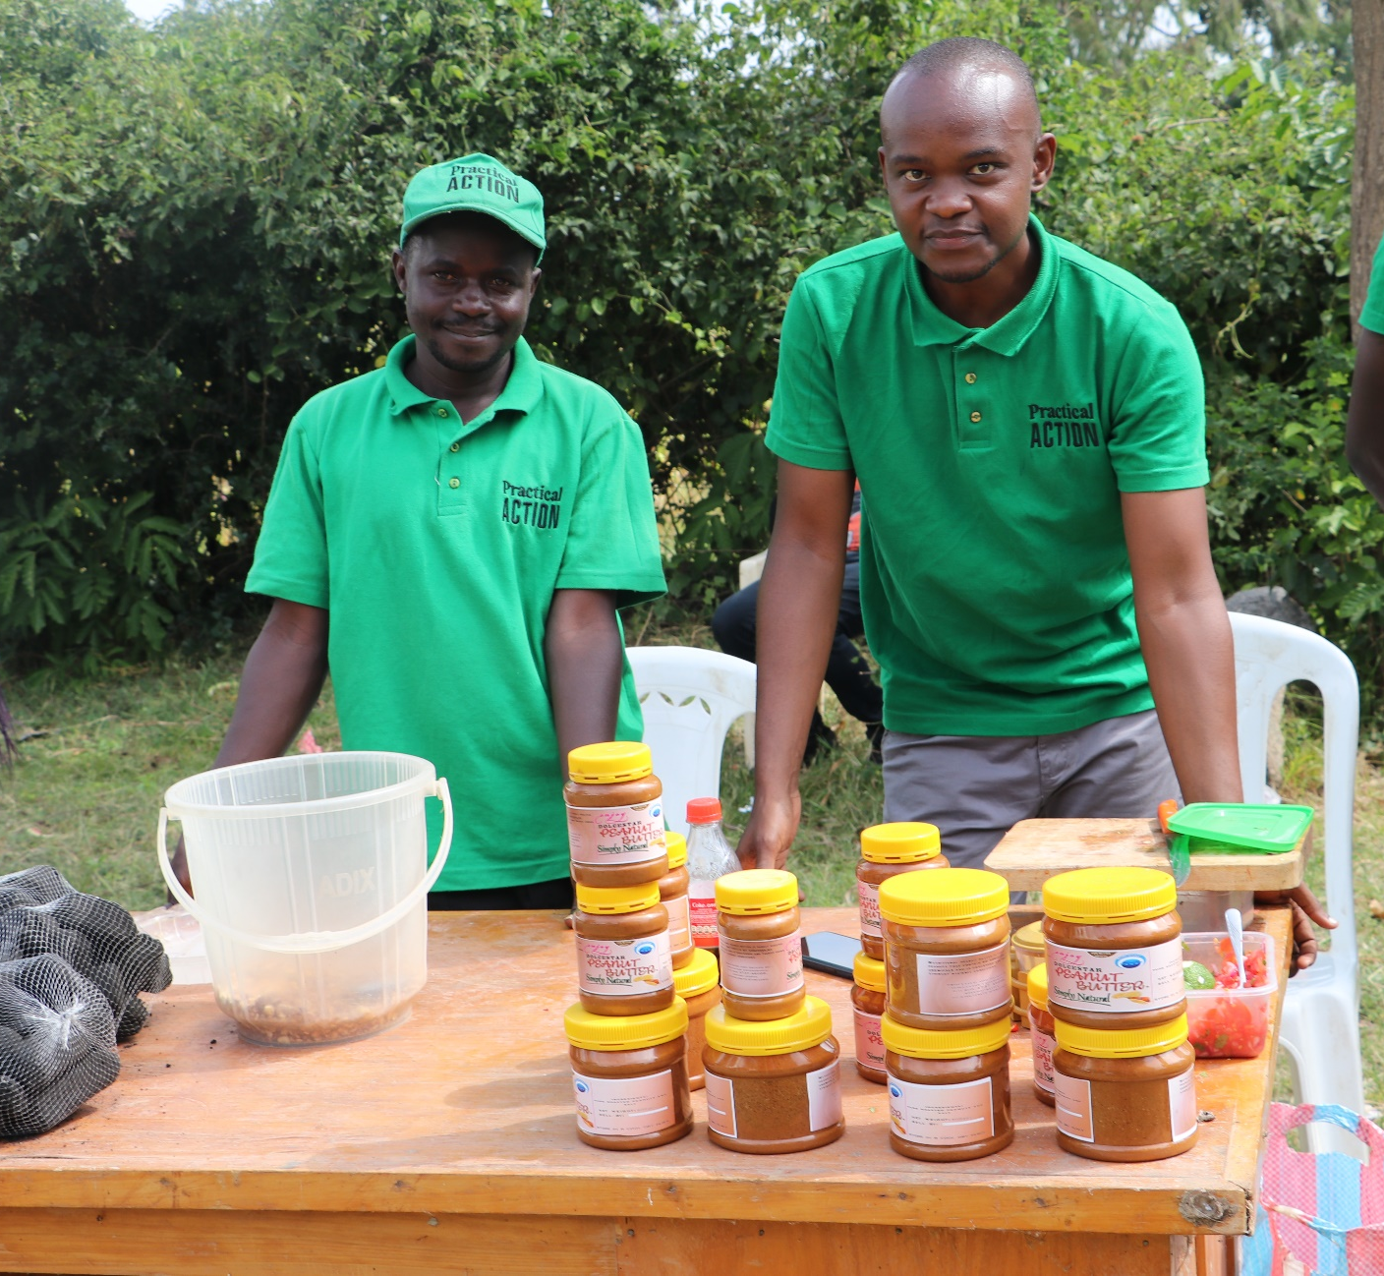
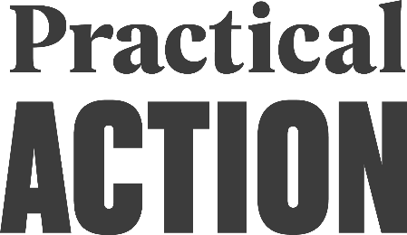
knowledge management officer
Practical Action
about us
We are an international development organisation putting ingenious ideas to work so people in poverty can change their world.
We help people find solutions to some of the world’s toughest problems. Challenges made worse by catastrophic climate change and persistent gender inequality. We work with communities to develop ingenious, lasting and locally owned solutions for agriculture, water and waste management, climate resilience and clean energy. And we share what works with others, so answers that start small can grow big.
We are committed to advancing gender equality and women’s empowerment through all our work. At a minimum, we ensure that all our work is gender sensitive, seeking gender transformative approaches as our overall ambition and in accordance with context.
We’re a global change-making group. The group consists of a UK registered charity with community projects in Africa, Asia and Latin America, an independent development publishing company and a technical consulting service. We combine these specialisms to multiply our impact and help shape a world that works better for everyone.

OUR AIMS
We help people find solutions to some of the world’s toughest problems, made worse by catastrophic climate change and persistent gender inequality. Our aims are to:
- Make agriculture work better for smallholder farmers, many of them women, so they can adapt to climate change and achieve a good standard of living
- Help more people harness the transformational effects of clean affordable energy and reduce avoidable deaths caused by smoke from indoor stoves and fires.
- Make cities in poorer countries cleaner, healthier places to live and work.
- Build disaster resilience into the lives of people threatened by hazards – reducing the risk of hazards and minimising their impact on lives and livelihoods.

PRACTICAL ACTION IN KENYA
In Kenya, Practical Action has a long history of addressing systemic barriers that prevent people from accessing energy that transforms their lives, helping communities and government make cities healthier and safer, making agriculture and markets work better for small holder farmers and supporting communities and government to become more resilient.
We use a mix of programming with communities and consultancy services with shapers of policy and practice to achieve our aims.

Practical Action
about the role
Practical Action puts emphasis on a systems approach to design programs for maximum impact. This means that we constantly endeavour to influence systems through our transformative work and use our learning for advocacy, while taking strategic opportunity to promote climate technology as a cross cutting theme across all of our work.
The Knowledge Management Officer oversees project level data collection, analysis and use as well as sharing of learning within the project and beyond. He/she will oversee the operationalization of effective and appropriate systems for measuring, storing, and sharing impact, learning and reporting in the project.
SCOPE

Title | Knowledge Management Officer
Reporting to | Senior Monitoring and Evaluation Officer
Matrix management | None
Direct reports | None
Matrix reporting | None
Member | NA
Relationships | Internal: Delivery Teams, BD and Communication teams External: Strategic Partners relevant to PA strategies
Financial scope | NA
Location | Kisumu, Kenya
Grade | 5
Travel requirements | Frequent, within project areas

ACCOUNTABILITIES
Leadership and Strategic Alignment
- Contribute to the development process of the strategic business plan (SBP), ensuring that change objectives are developed to achieve change in the lives of people that we work with.
- Provide data that supports routine quarterly and annual reporting of the SBP including reporting on the global indicators
- Provide data on the global indicators and show progress against targets

Strengthening Profile, Generating Funding and Managing Relationships
- Contribute to the proposal development process by participating in design workshops that build proposals
- Ensure that MEAL, gender assessments and learning and reflection is built into proposals (log frames and budgets)
- Ensure learning from program delivery feeds into organizational profile strengthening through stories of change and impact reporting.

Delivering Quality
- Support the Senior MEL officer to develop project level MEL plans that ensure tracking of programme results at different levels (outputs, outcomes and impact)
- Lead on delivering the project learning agenda
- Work with communication teams to develop and share knowledge to both internal and external stakeholders/audiences, including print and electronic information
- Maintain the online project database and ensure regular data updates and data integrity
- Effectively formulate, implement, and enforce proper data collection tools, processes and procedures for the project
- Monitor and evaluate overall progress on achievement of results including the sustainability of the project results
- Aggregate and analyse data from across the project interventions to contribute to management decision-making and reporting
- Conduct field visits for data validation and to monitor the quality and completeness of data sets; coordinate data collection at project sites and ensure timely compilation and reporting of data
- Work closely with project team and partners to ensure appropriate feedback mechanisms are incorporated into project
- Conduct project level review, learning and reflection sessions, as specified in the MEAL framework as a key accountability mechanism
- Collate project learning along with ensuring effective knowledge management between departments and affiliates to ensure the whole organisation benefits from and applies programmatic learning.
- Support quality project baseline, mid and end evaluations (using PLA tools) and ensure findings are reflected on and evaluation management responses prepared
- Ensure timely reporting: monthly, quarterly, annual and end of projects reports in accordance with donor requirements.
- Ensure gender and inclusions is embedded in MEAL

PERSON PROFILE
To be successful in the role, the ideal candidate will be able to demonstrate:
Experience & Knowledge  Essential  Desirable | - Bachelors’ degree in Development Studies or any other relevant degree and minimum of 3 years’ work experience in knowledge management, monitoring and evaluating programs with an organization with a robust M&E component.  - Experience of using indicators at output, outcome and goal level and developing tools to measure this  - A passion and experience of building in gender and inclusion into project design and MEAL aspects  - Strong technical skills including use of PowerBI or Tableau  - Strong experience in evaluation methodologies such as outcome mapping and Most Significant Change  - Successful track record of implementing effective MEL systems, including experience in quantitative and qualitative data collection and management.  - Experience in gathering learnings and then promoting their application  - Proven analytical and problem-solving skills to understand the range and content of the organization’s thematic work and provide practical solutions to operational challenges.  - Commitment to and ideally an understanding of safeguarding  - Fluency in Swahili and English  - Existing strong relationships and networks in the development space  - IT skills  - Knowledge of gender and safeguarding best practices  - A team player with excellent written and verbal communication skills – able to listen to others, to identify and share important/key information and to influence others in the uptake of new or adapted approaches.

